You’re Invited!
Join us for a Dine to Donate event at Arni’s Restaurant.
Bring this flyer with you, give it to your server or cashier,
and Arni’s will donate 20% of your check back to your organization!
Washington Township Swim Club
Monday, January 20th, 2025
All Day: 11am to 9pm
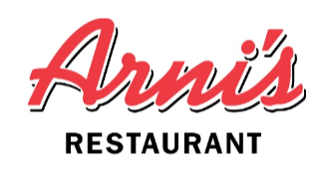
Arni’s Restaurant Order online at
4705 E 96th Street www.meetyouatarnis.com Indianapolis, IN 46240 ** Reservations not required
317-571-0077 but recommended for dine-in guests

